5 -2: Enhancement Three: Databases
Victor Haro Justiniano
SNHU
Cs499 Computer Science Capstone
Sherri Maciosek
04 /11/ 2026

For Category Three: Databases, I selected the Android inventory management application that I originally created in CS 360: Mobile Architecture and Programming. This artifact includes user login, local SQLite storage, SMS capability, and an inventory screen for adding, editing, deleting, and viewing items. I chose to reuse this artifact because it was already built around a database, which made it a strong fit for an enhancement focused on databases. It also gave me the chance to improve an earlier project and show growth by moving beyond basic data storage into more practical database design.
For this enhancement, I focused on making the SQLite database do more of the work instead of having the app pull every row and handle everything on the screen. I updated the item table so quantity is stored as an integer instead of text, kept the rule that prevents duplicate item names, and added indexes for the fields the app uses most during searching and sorting. I also created a combined query method so the database can handle the current search text, low stock filtering, and the selected sort option in one place. With that change, the database now handles searching by name, quantity, and date, along with low stock filtering and sorting by name or quantity before the results are returned to the activity. I kept the date sorting in DataGridActivity.java because the app still allows users to enter more than one date format, and that was still the most reliable place to handle it.
I included this artifact in my ePortfolio because it shows practical database skills in a way that is easy to see and test. Instead of only showing that I can save and retrieve records, this enhancement shows that I can improve how data is structured, queried, and managed within the application. The specific components that demonstrate my software development skills are the updated SQLite table design, the use of indexes to support faster lookups, the combined query method for search and filtering, and the connection between the user interface controls and the database results. These changes improved the artifact by making the data layer cleaner, reducing extra work in the activity, and helping the app return the right results more reliably for the user.
This enhancement aligns most strongly with outcome 4 because it demonstrates practical database techniques that help deliver a stronger software solution. It also supports outcome 5 by improving data integrity and reducing inconsistent data handling through numeric quantity storage, required fields, and clearer filtering behavior.
One of the main challenges during Enhancement 3 came from shifting more of the search and filtering work from the activity into the SQLite database. In Enhancement 2, I had already cleaned up the logic on the screen so the selected mode worked better and date sorting could handle both short and full year formats. Once I moved more of that behavior into the database for Enhancement 3, I had to test it again to make sure the new version of the query still behaved the same way. That is where a related issue came up with quantity search. When I searched for the value “2” for the quantity, the app did not return the expected result because the new query logic was not fully following the selected search option yet. I corrected that by updating the query so it searched for the matching column based on the selected mode. I kept the date sorting logic in DataGridActivity.java because that part had already been improved earlier and in my opinion, was still the most reliable way to handle the different date formats users could enter. This process helped me better understand that moving logic into a new layer of the app can bring back related issues that need to be tested and adjusted again.

Image 1: During testing for Enhancement 3, searching for the quantity “2” was not working the way it should after more of the search logic had been shifted from the activity into DatabaseHelper.java. This made it clear that the new database query still needed to be adjusted so it would match the selected search mode correctly.
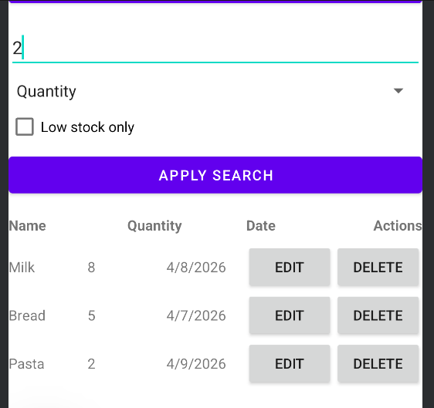

Image 2: This screenshot shows the updated query in DatabaseHelper.java after the fix was added. I changed the logic so the database would search the correct column based on the selected mode, which fixed the quantity search issue and better matched the intended behavior from Enhancement 2.
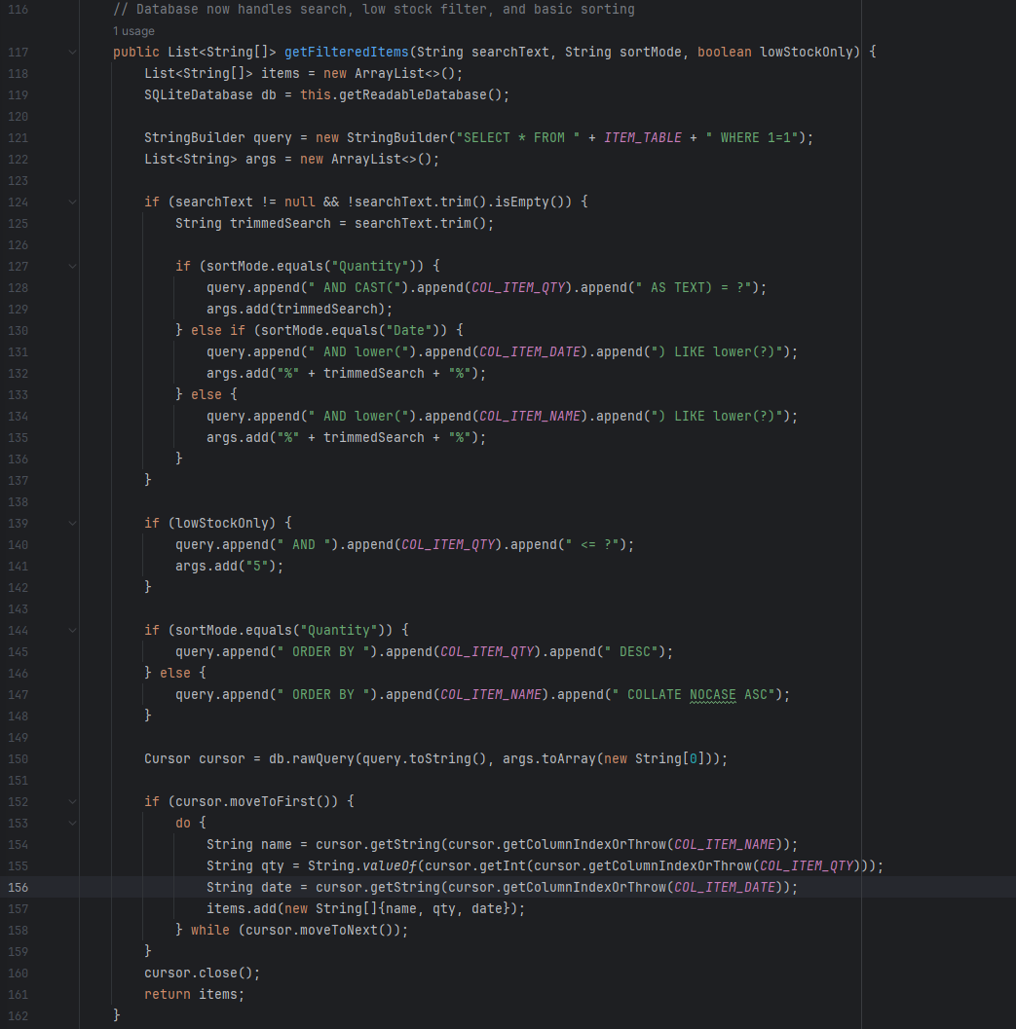
Image 3: After updating the query in DatabaseHelper.java, searching for the quantity “2” returned the expected item. This confirmed that the database search behavior was now working correctly after shifting that logic out of the activity and into the database helper.
